DOCTOR OF PHARMACY
and
MASTERS OF BUSINESS ADMINISTRATION
COMBINATION DEGREE PROGRAM

University of Florida
College of Pharmacy
College of Business

Teresa E. Roane, PharmD, BCACP
Faculty Advisor, PharmD/MBA Combination Degree Program
Associate Director, Center for Quality Medication Management
Clinical Assistant Professor, UF College of Pharmacy

Shauna Buring, PharmD
Associate Dean for Professional Education, UF College of Pharmacy

Combination PharmD/MBA Degree Program

Objectives

The goal of the combination Pharm.D./MBA program is to educate students to assume responsibilities as executives and administrators in pharmaceutical industry, and in health care delivery systems that provide pharmaceutical care to patients. The program is directed toward providing didactic and experiential education to students that will allow them to: (1) understand the major administrative functions in organizations delivering pharmaceutical products and care to patients; and (2) design strategies and policies to cope with the evolving health care environment.

The principal objective of the MBA program is to prepare students for successful careers in management positions in business and administration. The curriculum is structured so that students may concentrate their studies in specialty areas such as competitive strategy, finance, marketing, human capital, supply chain/logistics, or real estate. The MBA degree program is designed to give students: (1) conceptual knowledge for understanding the functions and behaviors common to all organizations, and (2) the analytical, problem-solving, and decision-making skills essential for effective management.

Program Description

Candidates for this program must first meet the entrance requirements, and be accepted into the Doctor of Pharmacy (PharmD) degree program in the College of Pharmacy. PharmD students may apply to the MBA program in the Graduate School of Business after successful completion of their second or third professional year. The Admissions Committee for the MBA Programs reviews, and selects, students for admission to the combination degree program. One full academic year is devoted to core course requirements in Business Administration. The combination degree programs share class credits, with credits for certain courses counting towards both degree programs, and will extend graduation from the PharmD program by one year. The program is not open to students who have already earned one of the two degrees. A student must satisfy the curriculum requirements for each degree. *Please note – pharmacy students must be assigned to the Gainesville campus for the completion of the MBA required coursework. Live class attendance is required for all MBA courses.

The combination degree curriculum provides for a total of 48 credits required for the MBA degree; 36 credits taken within the College of Business, and 12 credits taken within the College of Pharmacy. The Full-Time MBA curriculum is designed for individuals with diverse academic and professional backgrounds. No previous courses in business administration are required or expected of the candidates. In addition, a bachelor’s degree is not required to apply to the program.

The program design recognizes the importance of the various functional areas of management and the high probability that the career of a successful manager will span many functions. It provides a broad foundation of study covering all aspects of management, plus an opportunity to develop a concentration in one of several areas.

All MBA courses are offered in eight-week modules with two modules per semester. In all courses, the MBA program strives to maximize student-professor dialogue through dynamic and interactive teaching.

Admission Requirements

Admission to the UF MBA program is very selective. In reviewing applications, the Admissions Committee looks for evidence of intellectual ability, managerial promise, and community involvement. Strong interpersonal skills, communication ability, motivation, maturity, career focus, and leadership potential are also important qualities in prospective students. Applicants with two or more years of full time post-baccalaureate work experience are particularly attractive candidates for the combination degree program.

The Admissions Committee in the Graduate School of Business reviews the candidate’s academic record, scores on the Graduate Management Admission Test (GMAT) or Graduate Record Examination (GRE), and work experience. In addition, the committee considers maturity and personal qualities of leadership as indicated by the applicant’s letters of recommendation, interviews and other activities. Applicants are strongly encouraged to submit letters of recommendation from employers. Written essays are required and an interview may be necessary.

There are no specific prerequisite course requirements, although some background in statistics, calculus, and financial accounting may be helpful.

Interested pharmacy students should review information on the MBA program provided at the following web site: http://floridamba.ufl.edu/full-time/two-year/

Pharmacy students should express their interest in this program during the first professional year and seek the advice and direction of the faculty member in the Department of Pharmacotherapy and Translational Research who serves as a Program Coordinator for the combination degree curriculum with the Graduate School of Business.

New students are accepted to the combination PharmD/MBA program for the fall semester. The University of Florida MBA Program uses a rolling admissions process by which applications are considered as they are received. Applicants are highly encouraged to apply as early as possible. Specific procedures and deadlines are outlined in an application form, which can be obtained from the web site.

Applicants who have at least a 3.2 grade point average and a Graduate Management Admission Test (GMAT) score greater than 650 or Graduate Record Examination (GRE) score of 315 are especially encouraged to apply. The MBA Admissions averages currently sit around a 680 GMAT, 316 GRE and 3.4 GPA respectively. Applicants may take the GMAT or GRE at any time prior to applying for the program in the second professional year of the Doctor of Pharmacy program. Applicants for admission must submit satisfactory scores on the GMAT/GRE as well as transcripts for all previous academic work.

Students must petition the College of Pharmacy’s Academic and Professional Standards Committee for the opportunity to begin the MBA program once accepted to the program.

Students should maintain regular contact with the PharmD/MBA Faculty Advisor in the College of Pharmacy. The support and endorsement of the student’s application is required by the Department of Pharmacotherapy and Translational Research.

GMAT

The Graduate Management Admission Test (GMAT) is a nationally standardized skills test available anytime of the year at test centers throughout the world. Business schools use test scores to help evaluate candidates’ reading, reasoning, and problem-solving abilities. The GMAT is a standardized assessment. Each individual test that is administered contains the same format and areas of content. The test is comprised of three main sections: analytical writing, quantitative reasoning, and verbal reasoning. All test scores are good for 5 years. It is recommended applicants take the GMAT any time during the year prior to their year of admission. Details regarding the GMAT are available at http://www.mba.com/the-gmat.aspx

GRE
The Graduate Record Examinations (GRE) is a standardized test that is an admissions requirement for most Graduate Schools in the United States.^{[7]} The GRE is owned and administered by Educational Testing Service (ETS). According to ETS, the GRE aims to measure verbal reasoning, quantitative reasoning, analytical writing, and critical thinking skills that have been acquired over a long period of learning. The content of the GRE consists of certain specific algebra, geometry, arithmetic, and vocabulary. The GRE General Test is offered as a computer-based exam administered at Prometric testing centers.

Visits and Interviews

A campus visit is not a necessary part of the admission process, however competitive applicants will be invited and expected to complete an Admissions Interview before a final decision is reached. An appointment can be made through the MBA admissions office to discuss any aspect of the program or the admission process by contacting:

Sarah Carlson, Director of Student Affairs, Full-Time MBA Program
Phone: 352-273-1144
Email: sarah.carlson@warrington.ufl.edu
Hough Hall, MBA Programs Suite, Room 310
Warrington College of Business

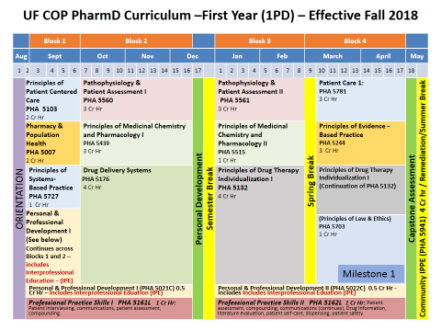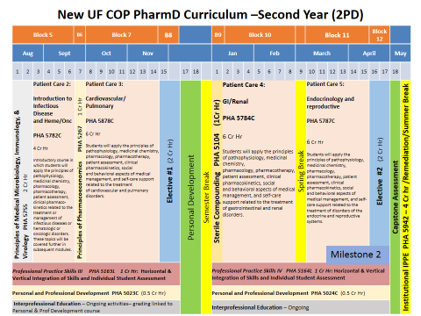
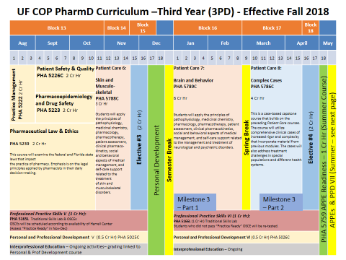
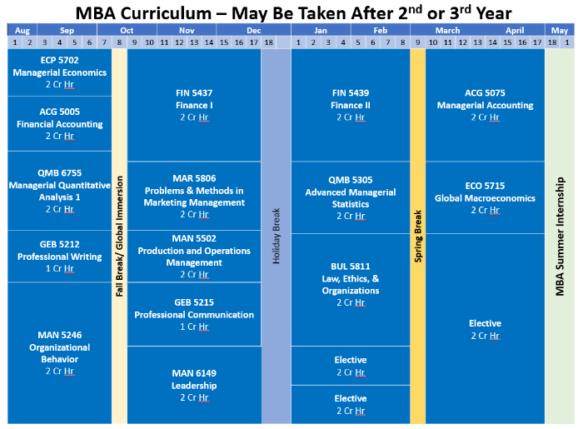

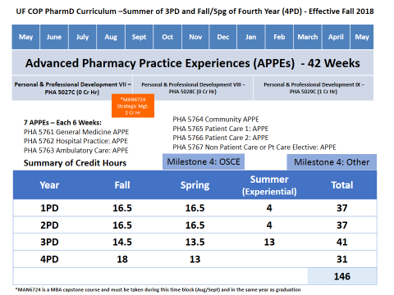
Summary: Combination Curriculum Coursework

PharmD Required Coursework
First Year (1PD): 37 credit hours
Principles of Patient Centered Care 2 cr.
Pharmacy and Population Health 2 cr.
Personal and Professional Development I & II 1 cr.
Professional Practice Skills I & II 2 cr.
Pathophysiology and Patient Assessment I & II 6 cr.
Principles of Medicinal Chemistry and Pharmacology I & II 4 cr.
Drug Delivery Systems 4 cr.
Principles of Drug Therapy Individualization 4 cr.
Patient Care 1 3 cr.
Principles of Law & Ethics 1 cr.
Principles of Evidence Based Pharmacy 3 cr.
Principles of Systems-Based Practice 1 cr.
Community Introductory Pharmacy Practice Experience 4 cr.

Second Year (2PD): 33 credit hours
Principles of Medical Microbiology, Immunology and Virology 2 cr.
Patient Care 2, 3, 4, & 5 22 cr.
Principles of Pharmacoeconomics 1 cr.
Professional Practice Skills III & IV 2 cr.
Personal and Professional Development III & IV 1 cr.
Sterile Compounding 1 cr.
Hospital Introductory Pharmacy Practice Experience 4 cr.

Third Year (3PD): 26 credit hours
Practice Management 2 cr.
Patient Safety & Quality 2 cr.
Pharmacoepidemiology and Drug Safety 2 cr.
Pharmaceutical Law & Ethics 2 cr.
Patient Care 6, 7 & 8 13 cr.
Professional Practice Skills V & VI 2 cr.
Personal and Professional Development V & VI 1 cr.
Electives (X 1) 2 cr.

Fourth Year (4PD): 44 credit hours
Capstone Course 1 cr.
Personal and Professional Development VII, VII, IX 1 cr.
Advanced Pharmacy Practice Experiences 42 cr.
Total required/elective PharmD credits 140

PharmD Elective Coursework in the Warrington College of Business
MBA Electives X 3 6 cr.
Dual counted electives credits 6 cr.

TOTAL CREDITS FOR PHARMACY DEGREE 146
MBA Required Coursework
Managerial Economics 2 cr.
Financial Accounting 2 cr.
Managerial Quantitative Analysis 1 2 cr.
Professional Writing 1 cr.
Organizational Behavior 2 cr.
Finance I: Asset Valuation, Risk & Return 2 cr.
Problems & Methods in Marketing Management 2 cr.
Production & Operations Management 2 cr.
Professional Communication 1 cr.
Leadership 2 cr.
Finance II: Capital Structure & Risk Management Issues 2 cr.
Advanced Managerial Statistics 2 cr.
Law, Ethics, and Organization 2 cr.
Managerial Accounting 2 cr.
Global Macroeconomics 2 cr.
Strategic Management 2 cr.
MBA Electives 2 cr.
Total required MBA course credits 36

MBA Coursework in the College of Pharmacy
Personal & Professional Development III ½ cr.
Personal & Professional Development VI ½ cr.
Principles of Pharmacoeconomics 1 cr.
Practice Management 2 cr.
Pharmaceutical Law & Ethics 2 cr.
Pharmaceutical Industry or Administration APPE 6 cr.
Dual counted electives credits 12

TOTAL CREDITS FOR MBA DEGREE 48 cr

For further information:
UF College of Pharmacy
Office for Student Affairs
PO Box 00495
Gainesville, FL 32610-0495
Phone: (352) 273-6217
Email: frontdesk@cop.ufl.edu
Web page: http://pharmacy.ufl.edu

The University of Florida is committed to nondiscrimination with respect to race, creed, religion, age, disability, color, sex, marital status, national origin, political opinions or affiliations, or veteran status. For disability assistance, call 352-392-1261 (V) or 352-392-3008 (TDD). Contact the Florida Relay Service at 800-955-877 (TDD) when offices do not list a TDD.

